*Organization*

Types of organizational data

Traditional data

This is **typically generated and maintained by all organizations**. It includes:

- **transactional data**  
 details relating to buying and selling, production activities and basic operations such as inf. Used to make employment decisions  
 - **intellectual property**  
 Patents, trademarks, product plans   
 (smt to help organization to gain economic advantage over competitors)  
 - **financial data**  
 income statements, balance sheets and cash flow statements

IoT = **large network of physical objects, such as sensors, software and other equipment  
 All of them are connected to the internet, with ability to collect and share data**.  
 The increase of size has led to creation of new area of interest in technology and business called ‘Big Data’

**The cube**

***McCumber Cube***

- is a **model framework created to help organizations establish and evaluate information security initiatives by considering all of the related factors that impact them**

It has **3 dimensions**:

**1 The foundational principles for protecting information systems  
 2 The protection of information in each of its possible states**

**3 The security measures used to protect data**

The foundational principles for protecting information

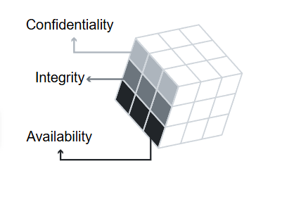

Confidentiality - set of **rules that prevents sensitive information from being   
 disclosed to unauthorized people**, resources and processes.   
  
 Method to ensure confidentiality   
 include **- data encryption,   
 - identity proofing**

**- two factor authentication**

Integrity - **ensures that system information/processes are protected from   
 intentional/accidental modification**

One way  
 use **hash function / checksum**

Availability - **authorized users are able to access systems and data when and where needed**   
   
 Ways:

**Maintaining equipment   
 performing hardware repairs  
 keeping operating systems and softwear up to date  
 creating backups**

The protection of information in each state

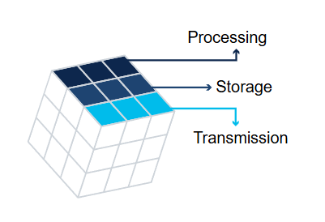

Processing - **refers to data that is being used to perform an operation such as updating a   
 database record**

Storage - **refers to data stored in memory or on a permanent storage device such as a HDD, USB…**

Transmission - **refers to data traveling between information systems**

The security measures used to protect data

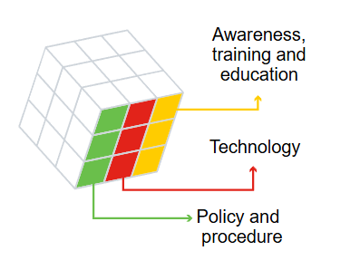

Awareness, training and education - **measures put in place by an organization to ensure that users are knowledgeable about potential security threats and the actions they can take to protect information systems**

Technology - **software and hardware based solutions to protect information systems such as firewalls,…**

Policy and procedure - refers to **administrative controls that provide a foundation for how an organization implements information assurance,** (incident response, plans and practice guidelines)

Consequences of a security breach

Potential consequences of a security breach can be:

1. Reputation damage  
    - it can have a negative long-term impact on an organization’s reputation  
    - customers particularly those impacted, will need to be notified and may seek   
    compensation and/or turn to a competitor
2. Vandalism  
    - hacker/group may vandalize an organization’s website, minor like changing email   
    or phone to big ones
3. Theft  
    - it often involves an incident where sensitive personal data has been stolen  
    - cybercriminals can make this information public or exploit it to steal individuals   
    money or identity
4. Loss of revenue  
    - financial impact of security breach can be devastating  
    - example hacker takes down online shop’s website, demand of further investment I  
    in an organization’s security, large fines or penalties
5. Damaged intellectual property - devastating impact on the competitiveness of an organization, particularly if   
    hackers are able to get their hands on confidential documents, trade secrets or   
    intellectual property